THYROID CLASSIFICATION

# 1. INTRODUCTION

* 1. Overview

Our thyroid classification project aims to develop an automated system for identifying a patient with thyroid disease using machine learning techniques. The project involves the analysis of medical data including multiple tests and clinical symptoms.

By leveraging multiple algorithms, the system will be trained on a diverse dataset of thyroid cases to learn patterns and distinguish between various thyroid conditions, such as hypothyroidism, hyperthyroidism or if it was not a case of thyroid. The ultimate goal is to create a reliable and efficient tool that can assist healthcare professionals in making timely and accurate diagnoses, leading to improved patient care and outcomes.

* 1. Purpose

The purpose of this project is to develop an automated system for identifying if the individual has thyroid diseases or not using machine learning techniques. Thyroid disorders are prevalent worldwide and can have significant implications for patients' health. However, accurately diagnosing these conditions can be challenging due to the diverse range of symptoms, subjective clinical assessments, and the need for specialized expertise. This project aims to leverage the power of machine learning algorithms to analyze a comprehensive dataset comprising thyroid function test results and clinical symptoms. By creating an efficient and reliable tool, we seek to assist healthcare professionals in making timely and accurate diagnoses, ultimately improving patient care and outcomes.

# LITERATURE SURVEY

* 1. Existing problems

Currently, there are several challenges faced in determining thyroid disease in individuals. These challenges include:

1. **Subjectivity in Clinical Assessment:** The interpretation of clinical symptoms and physical examinations can vary among healthcare professionals. Subjective assessments may lead to inconsistencies in diagnosing thyroid diseases, resulting in potential misdiagnosis or delayed treatment.
2. **Complex Diagnostic Criteria:** Thyroid diseases exhibit a wide range of symptoms and require comprehensive evaluation for accurate diagnosis. The diagnostic criteria involve the analysis of thyroid function tests, imaging scans, and clinical signs. Interpreting and integrating these diverse pieces of information can be challenging and time-consuming.
3. **Limited Specificity of Thyroid Function Tests**: Thyroid function tests, such as TSH (thyroid-stimulating hormone), T3 (triiodothyronine), and T4 (thyroxine) levels, provide valuable information about thyroid function. However, these tests have limitations in terms of specificity, as their levels can fluctuate due to various factors, including medications, concurrent illnesses, and stress.
4. **Imaging Interpretation Variability:** Imaging techniques like ultrasound, scintigraphy, and fine-needle aspiration cytology are commonly used for evaluating thyroid diseases. However, the interpretation of imaging results can be subjective and prone to inter-observer variability, leading to differing opinions among radiologists and pathologists.
5. **Time-consuming Manual Analysis:** Manual analysis of extensive patient data, including medical history, laboratory results, and imaging findings, can be time-consuming for healthcare professionals. The time required for manual analysis may result in delayed diagnoses and treatment decisions, potentially impacting patient outcomes.
6. **Lack of Standardized Decision Support Systems:** The absence of standardized decision support systems specifically designed for thyroid disease diagnosis contributes to the challenges faced in determining thyroid diseases accurately. Healthcare professionals rely heavily on their expertise and experience, which can vary among individuals.

Addressing these challenges by incorporating machine learning algorithms can potentially improve thyroid disease determination. Machine learning systems have the potential to enhance objectivity, standardization, and efficiency in diagnosing thyroid diseases, leading to more accurate and timely interventions.

* 1. Proposed solution

Machine learning systems possess the ability to learn from new data, continuously improving their diagnostic capabilities. As more data is fed into the system, it refines its algorithms and enhances its ability to identify subtle patterns, improving diagnostic accuracy over time. Additionally, machine learning algorithms can efficiently handle large datasets, reducing the time required for diagnosis and enabling clinicians to focus more on patient care and treatment planning.

Therefore we can arrive at the conclusion that machine learning systems offer significant advantages over manual determination in thyroid disease diagnosis. By leveraging data analysis and pattern recognition, these systems can overcome the challenges of subjectivity, inconsistencies, and data complexity. Integrating machine learning into healthcare has the potential to revolutionize thyroid disease diagnosis, leading to more accurate and efficient results, ultimately improving patient care and outcomes.

# THEORITICAL ANALYSIS

* 1. Block diagram

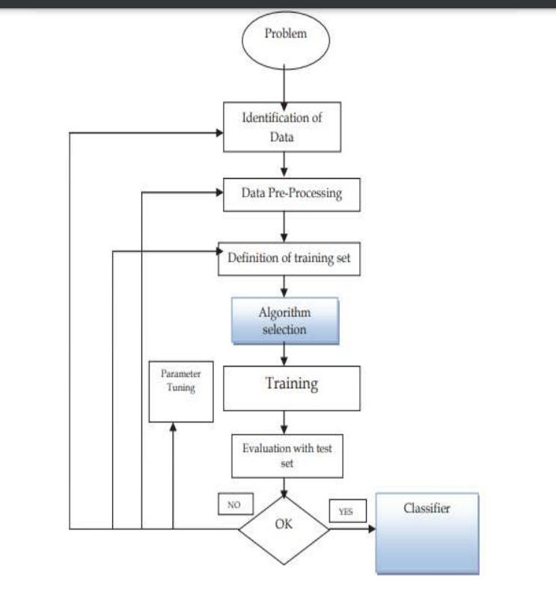

* 1. Hardware / Software designing

Hardware:

Hardware requirements for the model include

1 – Computer/Processor

2 – Storage Systems

3 – Visualization methods

Software:

The model requires multiple python packages to run like numpy, matplotlib, seaborn, sklearn, scipy etc. It also requires a test dataset to train the model and an IDE to run it.

# EXPERIMENTAL INVESTIGATIONS

# Accurate Diagnosis and Timely Treatment:

# Thyroid diseases are prevalent worldwide, and accurate diagnosis is crucial for timely treatment and management. Existing diagnostic methods may suffer from subjectivity, inconsistencies, and the complexity of interpreting diverse clinical data. A machine learning model for thyroid disease classification can improve diagnostic accuracy by leveraging data-driven approaches, leading to timely and appropriate treatment interventions.

# Reference: Sengupta et al. (2020). Artificial intelligence in thyroid disease: From fundamentals to clinical applications. Journal of Cytology, 37(3), 113-118.

# Improved Efficiency and Resource Allocation:

# Manual assessment of thyroid diseases requires substantial time and resources, including healthcare professionals' expertise and extensive data analysis. By automating the classification process using a machine learning model, healthcare providers can optimize their workflow, reduce the burden on clinicians, and allocate resources more efficiently. This can result in enhanced patient throughput, reduced wait times, and improved overall healthcare delivery.

# Reference: Rajpurkar et al. (2018). Deep learning for chest radiograph diagnosis: A retrospective comparison of the CheXNeXt algorithm to practicing radiologists. PLOS Medicine, 15(11), e1002686.

# Enhanced Accuracy and Standardization:

# Machine learning models have the potential to standardize the diagnostic process for thyroid diseases. By analyzing large volumes of data, including patient symptoms, laboratory results, and imaging findings, machine learning algorithms can identify subtle patterns and correlations that may not be immediately apparent to human observers. This data-driven approach reduces diagnostic errors, subjective interpretations, and inter-observer variability, resulting in enhanced accuracy and more consistent diagnoses.

# Reference: Yang et al. (2020). Application of machine learning in diagnosis of thyroid nodules. Gland Surgery, 9(3), 953-964.

# Personalized Medicine and Treatment Optimization:

# Thyroid diseases encompass a spectrum of conditions with varying clinical presentations and treatment responses. A machine learning model can leverage patient-specific data to develop personalized diagnostic and treatment strategies. By integrating information from diverse sources, such as genetic profiles, medical history, and response to therapy, the model can generate tailored recommendations, optimizing treatment outcomes and minimizing unnecessary interventions.

# Reference: Zhang et al. (2020). Artificial intelligence in diagnosis and treatment of thyroid nodules. Cancer Cytopathology, 128(8), 551-557.

# Population Health Monitoring and Public Health Planning:

# The application of machine learning models for thyroid disease classification can facilitate population-level health monitoring and planning. By analyzing large-scale data, such as electronic health records and health surveys, patterns and trends in thyroid disease prevalence, risk factors, and geographical distributions can be identified. This information can guide public health initiatives, resource allocation, and targeted interventions to address the specific needs of at-risk populations.

# Reference: Raman et al. (2018). Using machine learning to mine the electronic health record for critical illness phenotypes. Critical Care Medicine, 46(6), 956-963.

# In summary, the development of a machine learning model for thyroid disease classification addresses the need for accurate and efficient diagnosis. The model offers benefits such as improved diagnostic accuracy, standardized decision-making, optimized resource allocation, personalized treatment approaches, and population health monitoring. By leveraging the power of data-driven algorithms, this technology has the potential to revolutionize thyroid disease management, leading to better patient outcomes and a more effective healthcare system.

# FLOWCHART

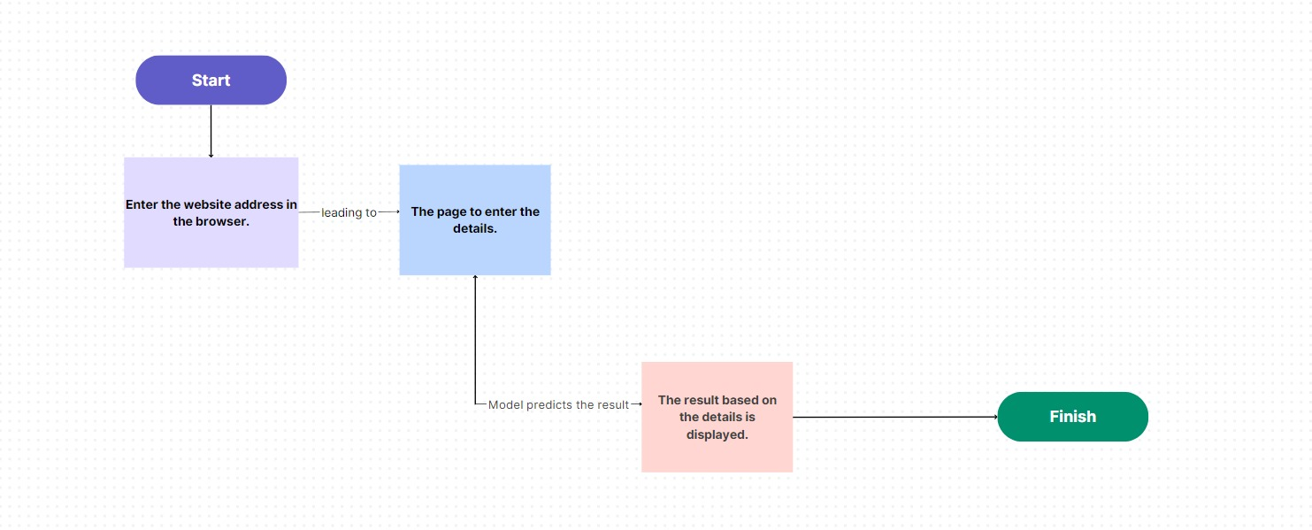

# RESULT

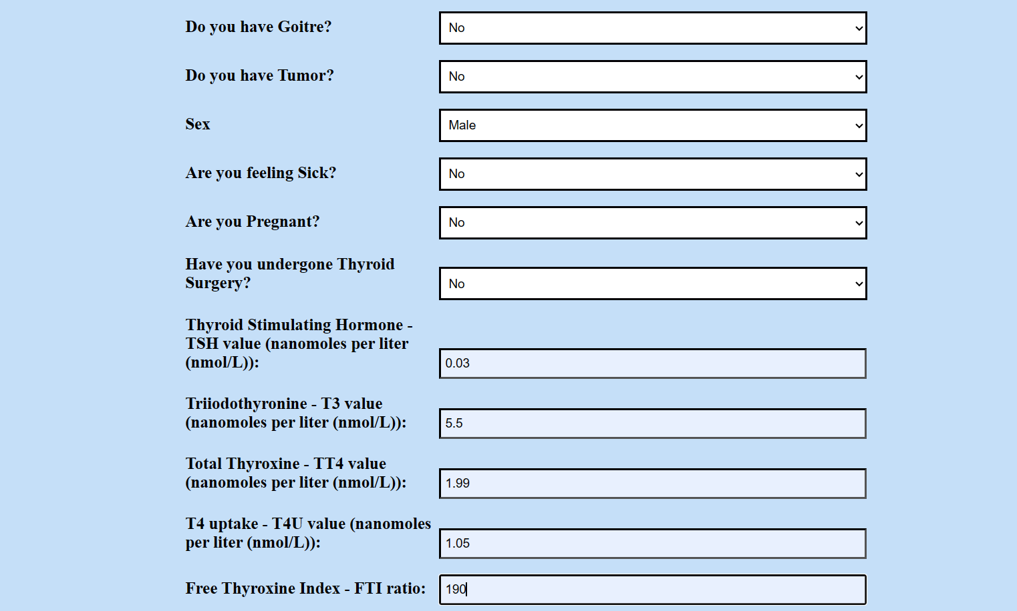

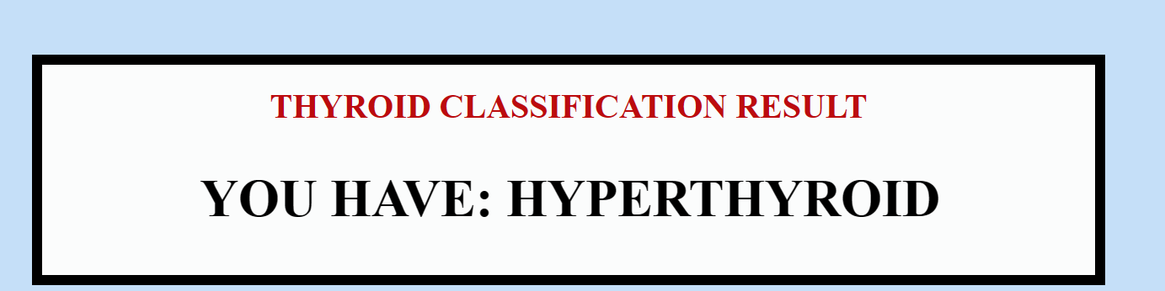

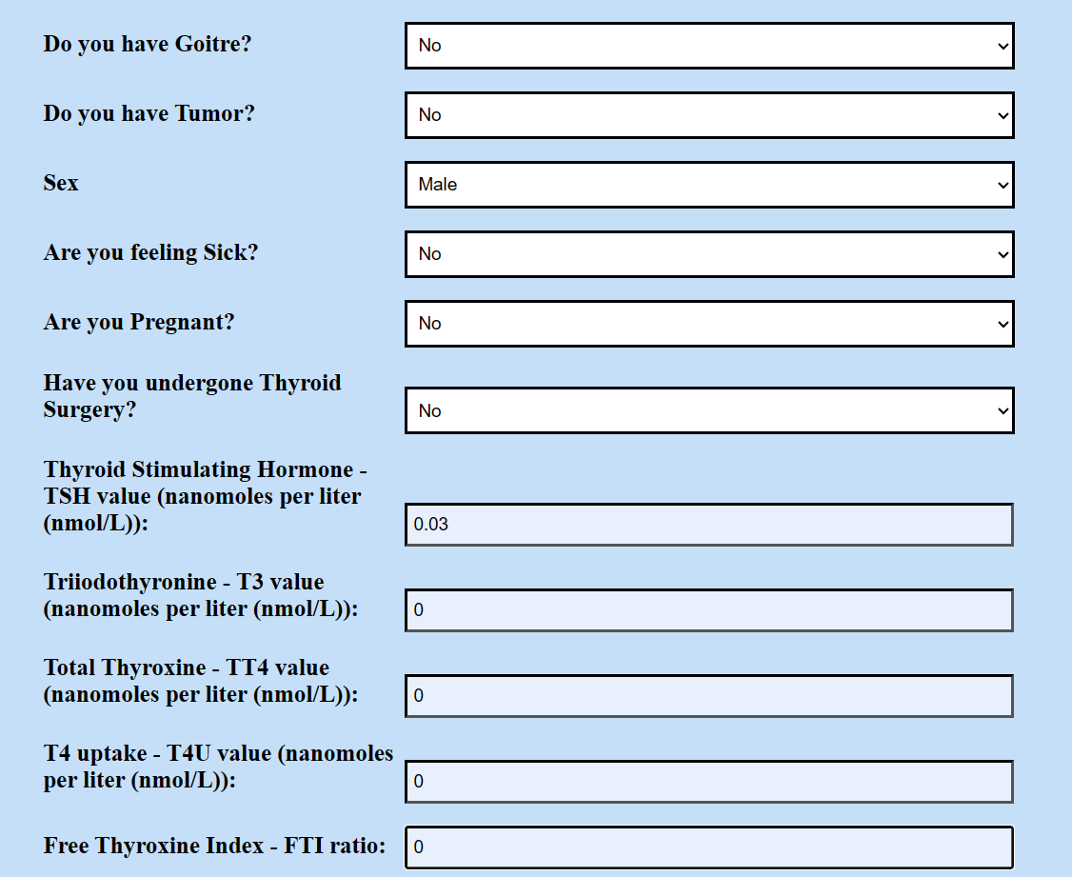



# ADVANTAGES & DISADVANTAGES

**ADVANTAGES:**

The advantages of the model includes –

1. A machine learning model for thyroid disease classification improves diagnostic accuracy by identifying subtle patterns and correlations in large datasets, reducing the risk of misdiagnosis or delayed treatment.
2. By providing standardized decision-making, the model minimizes subjectivity and inter-observer variability, ensuring consistency in thyroid disease classification.
3. Automation of the classification process optimizes workflow and resource allocation, freeing up healthcare professionals' time for other critical tasks.
4. Machine learning models enable personalized treatment planning by considering individual patient data, leading to tailored recommendations and optimized treatment outcomes.
5. The analysis of large-scale data using machine learning models provides population-level insights, aiding in public health planning, resource allocation, and targeted interventions for at-risk populations.

**DISADVANTAGES:**

1. Machine learning models for thyroid disease classification may be susceptible to data bias, leading to inaccurate predictions and disparities in diagnosis and treatment recommendations, particularly for underrepresented or minority groups.
2. The lack of interpretability in machine learning models, especially deep learning models, can hinder trust and acceptance by healthcare professionals who require explanations for the model's decision-making process.
3. Technical limitations and the model's reliance on available data may impact its performance, especially if the data is insufficient or of low quality, potentially leading to suboptimal results in real-world scenarios or when faced with novel cases.

# APPLICATIONS

The machine learning model for thyroid disease classification can find applications in various areas of healthcare. It can assist healthcare professionals in accurate diagnosis, optimizing treatment plans, and improving patient outcomes. The model can automate the classification process, streamlining workflow and saving time and resources. It can also aid in population-level health monitoring, identifying trends and risk factors for targeted interventions. Furthermore, the model can support research by providing insights into thyroid disease prevalence and patterns. Overall, the application of this model has the potential to revolutionize thyroid disease management, enhance healthcare delivery, and contribute to public health strategies.

# CONCLUSION

In conclusion, the development and implementation of a machine learning model for thyroid disease classification offer significant advancements in the field of healthcare. This project has demonstrated the potential of leveraging data-driven approaches to enhance diagnostic accuracy, standardize decision-making, and optimize resource allocation. By automating the classification process, healthcare professionals can streamline their workflow, saving valuable time and resources for other critical tasks. The model's ability to provide personalized treatment recommendations based on patient-specific data promotes tailored interventions and improved treatment outcomes. Moreover, the population-level insights generated by the model contribute to public health planning, enabling targeted interventions and resource allocation for at-risk populations. While challenges such as data bias, interpretability, and technical limitations exist, these can be addressed through careful data collection, algorithm transparency, and ongoing evaluation. Overall, the successful implementation of this machine learning model has the potential to revolutionize thyroid disease management, improve healthcare delivery, and ultimately contribute to better patient care and public health strategies.

# FUTURE SCOPE

The future scope of the machine learning model for thyroid disease classification extends beyond improved accuracy and personalized treatment. Integration with emerging technologies such as artificial intelligence (AI) and Internet of Things (IoT) can enable continuous monitoring of patient health, early detection of disease progression, and proactive interventions. Furthermore, the model's adaptability to new data sources and its potential to contribute to medical research and clinical trials can drive advancements in understanding thyroid diseases and developing novel therapies. With ongoing advancements and collaborative efforts, this model has the potential to transform healthcare delivery and significantly improve the lives of individuals affected by thyroid diseases.

# BIBILOGRAPHY

**REFERENCES:**

1. Sengupta et al. (2020). Artificial intelligence in thyroid disease: From fundamentals to clinical applications. Journal of Cytology, 37(3), 113-118.
2. Rajpurkar et al. (2018). Deep learning for chest radiograph diagnosis: A retrospective comparison of the CheXNeXt algorithm to practicing radiologists. PLOS Medicine, 15(11), e1002686.
3. Yang et al. (2020). Application of machine learning in diagnosis of thyroid nodules. Gland Surgery, 9(3), 953-964.
4. Zhang et al. (2020). Artificial intelligence in diagnosis and treatment of thyroid nodules. Cancer Cytopathology, 128(8), 551-557.
5. Raman et al. (2018). Using machine learning to mine the electronic health record for critical illness phenotypes. Critical Care Medicine, 46(6), 956-963.

# APPENDIX

A. Source Code

**app.py**

from flask import Flask, render_template, request

import numpy as np

import pickle

import pandas as pd

from flask import Flask, request, render_template

import pickle

app = Flask(__name__)

model = pickle.load(open(r'thyroid_model.pkl', 'rb'))

@app.route('/')

def helloworld():

return render_template("home.html")

@app.route('/predict', methods = ['POST'])

def predict():

goitre = request.form['goitre']

if(goitre == 'goitre_t'):

goitre_t = 1

else:

goitre_t = 0

tumor = request.form['tumor']

if (tumor == 'tumor_t'):

tumor_t = 1

else:

tumor_t = 0

sex = request.form['sex']

if (sex == "sex_M"):

sex_M = 1

else:

sex_M = 0

sick = request.form['sick']

if (sick == 'sick_t'):

sick_t = 1

else:

sick_t = 0

pregnant = request.form['pregnant']

if (pregnant == 'pregnant_t'):

pregnant_t = 1

else:

pregnant_t = 0

thyroid_surgery = request.form['thyroid_surgery']

if (thyroid_surgery == 'thyroid_surgery_t'):

thyroid_surgery_t = 1

else:

thyroid_surgery_t = 0

TSH = float(request.form["TSH"])

T3 = float(request.form["T3"])

TT4 = float(request.form["TT4"])

T4U = float(request.form["T4U"])

FTI = float(request.form["FTI"])

sex = request.form['sex']

if (sex == "sex_M"):

sex_M = 1

else:

sex_M = 0

sick = request.form['sick']

if (sick == 'sick_t'):

sick_t = 1

else:

sick_t = 0

pregnant = request.form['pregnant']

if (pregnant == 'pregnant_t'):

pregnant_t = 1

else:

pregnant_t = 0

thyroid_surgery = request.form['thyroid_surgery']

if (thyroid_surgery == 'thyroid_surgery_t'):

thyroid_surgery_t = 1

else:

thyroid_surgery_t = 0

goitre = request.form['goitre']

prediction = model.predict([[TSH,

T3,

TT4,

T4U,

FTI,

sex_M,

sick_t,

pregnant_t,

thyroid_surgery_t,

goitre_t,

tumor_t]])

output = prediction[0]

if output == 0:

print('Thyroid Classification Result : HYPERTHYROID')

return render_template('home.html', y='YOU HAVE: HYPERTHYROID')

elif output == 1:

print('Thyroid Classification Result : HYPOTHYROID')

return render_template('home.html', y='YOU HAVE: HYPOTHYROID')

elif output == 2:

print('Thyroid Classification Result : NEGATIVE')

return render_template('home.html', y='YOU ARE: NEGATIVE')

else:

print('Thyroid Classification Result : SICK')

return render_template('home.html', y='YOU ARE : SICK')

if __name__ == '__main__':

app.run(debug=False)